Advancing Community Equity and Upward Mobility (ACE-UP) - Application for Participation

Background
The U.S. postsecondary system is at a critical juncture. Community colleges create viable, affordable pathways for job seekers historically excluded from economic advancement to access high-demand, livable wage jobs. However, as a result of structural barriers and a legacy of historic racism, outcome disparities exist both in the classroom and the labor market for community college students, that impair student economic mobility, undermine institutional success, and negatively impact employers’ bottom lines. From 2004 to 2020, the gap in graduation rates between Black and White students grew from 4 to 11 percent. At a time when postsecondary credential attainment is associated with higher earnings, protective effects against unemployment, and even better health outcomes, equity gaps persist. Fifty-percent of white adults in the U.S. hold college degrees, compared to 34% Black adults and 28% Hispanic adults. Since start of the pandemic in 2020, Black community college enrollment has also declined by 18% percent. Such is significant, considering the households of Black community college graduates earned over $16,000 more than households without associate’s degrees.

Advancing Community Equity for Upward Mobility (ACE-UP)
Corporation for a Skilled Workforce (CSW), with support from Lumina Foundation, is convening 15 forward-thinking postsecondary institutions and their industry partners in a first of its-kind community of practice, Advancing Community Equity and Upward Mobility (ACE-UP). ACE-UP seeks to address growing postsecondary and labor market disparities by bringing together community college and industry leaders to design and uplift tangible strategies to align education and training, increase access to employment, and advance equitable employment outcomes for people of color. During virtual meetings, one-on-one coaching, peer mentoring, and resource sharing, colleges and their industry partners will build capacity to identify and resolve institutional and workplace equity issues using best and emerging strategies.
Through participation in ACE-UP, colleges and industry partners will:
- Access a peer forum to work collaboratively to identify systemic challenges and create shared solutions.
- Deepen skills and competencies to identify the drivers of outcome disparities and incubate and apply proven solutions.
- Build capacity to collaborate and problem-solve more deeply with industry while addressing underlying equity issues.
- Contribute to research on how the adoption of equity metrics and goals can drive policy and practice change;
- Be part of a larger, more diverse community of college and industry leaders developing policies that advance economic opportunity for students from marginalized groups and meet the talent development needs required for long-term economic competitiveness.

Benefits of Participation: Participation in ACE-UP is free to you and your institution. Participants will join a national community of college and industry leaders, workforce practitioners, and content experts committed to advancing postsecondary and labor market equity. With this valuable experience participants will: 1) attend virtual meetings featuring experts with first-hand experience implementing proven equity practices and policies; 2) attend an in-person convening with other ACE-UP members and Department of Labor Strengthening Community Colleges grantees in Washington D.C.; 3) access tools and resources developed and deployed by peers; 4) contribute knowledge to the field on equity-centered practices in community college career programs (or community college-industry partnerships); 5) interact with peers from across the Strengthening Community Colleges network and other equity-minded institutions; 6) receive coaching and technical assistance from CSW staff that is centered around the Five Elements of Success Framework.

Five Framework Elements of Success:

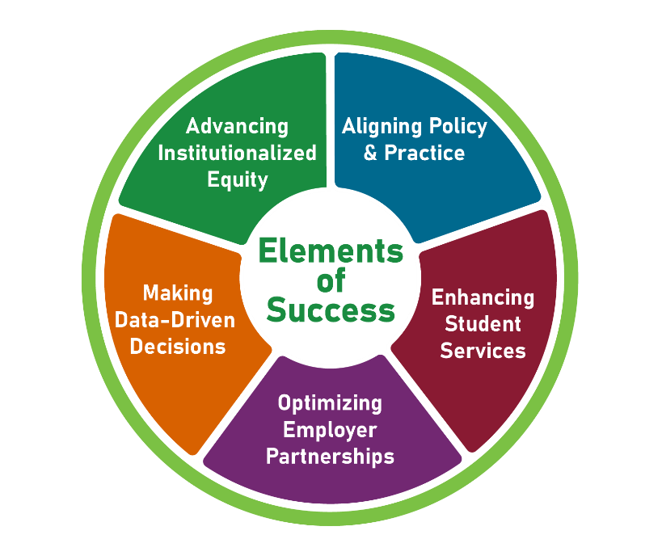
- Advancing Institutionalized Equity: Develop tools and strategies that identify and address equity gaps that directly or indirectly impact labor market access and outcomes for underrepresented and marginalized populations.
- Aligning Policy & Practice: Align, apply, and connect with business policies and initiatives to improve student/job seeker/incumbent worker and employer conditions that support improved longer-term outcomes.
- Cultivating Employer Partnerships: Engage employers in providing insights into industry and workforce needs; collaborate on design, implementation, and investment of resources; provide value added connections and resources; apply and provide feedback on equitable programs, strategies, and practices; and develop longer-term relationships that go beyond customer to strategic partner.
- Enhancing Student Services: Design and employ an interconnected continuum of processes and services that enables effective recruitment of targeted populations; assesses the needs of each individual; deliver training to prepare participants for work in quality jobs; coordinate job development and job placement services to match the skills of participants with the requirements of employers; and, collaborate with a range of partners to provide supportive services to address barriers to job retention and advancement.

- Making Data-Driven Decisions: Effectively utilize disaggregated data related to labor market, industry and occupational trends, program assessment and learner outcomes to inform and guide key decisions regarding program investments, planning, implementation, and improvements.

How to Apply
Through this application we invite community colleges and other postsecondary providers to submit proposals to join the ACE-UP community of practice.
Applicants should indicate their institution’s commitment to equity and where it falls according to the stages of development defined below:
  - Equity planning is at the design stage.
  - The applicant is at the early implementation stage in its equity work.
  - The applicant is at the full implementation stage in its equity work.
Community college applicants must indicate the names and roles of 3-5 staff who will participate in ACE- UP activities, indicating the departments they represent (workforce development, advising, student services, academics, institutional research, and/or other they believe have a role to contribute to this work). Each institution must name a team lead who will serve as the primary point of contact and will attend all activities as part of this community of practice. Additionally, the names and roles of industry partners, representing employers, industry/trade associations, and/or labor unions should be included, if available. Applicants selected to participate in ACE-UP must commit to:

Attending and actively participating in 7-12 virtual meetings between April 2024 and June 2025

Attending the ACE-UP in-person meeting convening in Washington D.C. in June 2024 (two representatives from each institution will be funded to attend)

Selecting and piloting applicable strategies with industry partners while documenting key lessons learned, successes, and

Contributing resources and tools for the purpose of supporting peer implementation, and, later, systems-level

Providing regular, ongoing feedback to help inform meeting content, subject matter expert selection, and CSW’s technical assistance and coaching strategy.

Participating in webinars uplifting key lessons learned and strategies piloted, for the purpose of advancing equitable practices

Working with researchers from The Urban Institute who will conduct virtual interviews with staff from selected institutions, review documents, and available aggregate data, to inform case studies and CoP

Community of Practice Details

Eligible applicants: Public or private not-for-profit community colleges, historically Black community colleges, Hispanic-serving community colleges, and/or tribal community colleges, and their industry partners. ACE-UP seeks to convene a diverse array of community colleges, both large and small, rural and urban, and those with a focus on a wide array of industries. Industry partners can include employers, industry trade associations, and/or organized labor.

Application Submission: Applications must be submitted via email. Please record responses to the questions on the application for participation below and submit in .doc or .pdf format to ace@skilledwork.org.

Due Date: Proposal Forms are due March 14, 2024 (formerly February 29, 2024)
Review of applications: Applications will be reviewed in March by the CSW professionals who make up the ACE-UP team.
Selection of applicants: To select a diverse cohort, the ACE-UP team is committed to an open and equitable selection process. We recognize that institutions may be at varying stages in implementing equity initiatives. Our goal is to assemble the best possible range of participating institutions to promote idea generation, learning, and bringing ideas to scale with a community of committed practitioners, advancing equity in their institutions. Applications serve as a demonstration of initiative and willingness to participate, and will be measured against the following rubric:

Criteria | Points
Statement of Interest | 25
Team | 15
Industry Partners | 20
Industry Engagement Capabilities | 40

All applicants and those invited to join will be notified on or about April 1, 2024.
Memorandum of Understanding: An MOU will formalize the arrangement between the selected applicant and Corporation for a Skilled Workforce.
Duration: Participation in the Initiative will extend from April 2024 to June 2025.
Questions: Questions about the application may be sent to Diamond Dickerson ace@skilledwork.org.

ACE-UP APPLICATION TO PARTICIPATION
Please document your answers to the following questions and submit to ace@skilledwork.org, in a .doc or .pdf format by March 14, 2024.

Type of Applicant
Public Community or technical college Private Community or technical college
Indicate if you are one of the following:
MSI HBCU HSI
Tribal College

Lead Contact Name:
Lead Contact Title:
Lead Contact Email:

Name and Address of Institution:
Size of Institution (number of students):

Statement of Interest (up to 2 pages): Describe your interest in the community of practice. This should reflect your institution’s current equity commitment, readiness to work with industry partners to close equity gaps, and your vision for change. The statement should address such questions as:
What equity gaps are you observing for students of color relating to worker advancement, retention and success?

What evidence do you have of your institution’s commitment to equity—Is it reflected in the institution’s mission or vision? Is it included as a goal in the strategic plan? Are there metrics associated with equity? Has the leadership spoken publicly or written about the commitment to equity?

What strategies are you most interested in learning about and applying?

What do you hope to get out of participation in this community of practice?
Team (up to 2 pages): Brief description of your lead contact and proposed team. We recommend 3-5 person teams that include decision makers in distinct roles and departments. The participation of staff that interact directly with industry is highly encouraged to allow for strategy application at partner workplaces. Participating staff should be: 1) interested in designing and implementing strategies to increase access to employment and workplace equity; 2) committed to achieving employment equity through educational and economic opportunity with a particular focus on Black, Hispanic and Native American populations; 3) eager for the opportunity to collaborate with geographically diverse institutional and industry leadership to develop and apply strategies to close workplace equity.

Describe your team and what role does each team member play?

Why is this the right group for advancing postsecondary and labor market equity within your community?

Industry: Please provide a brief description of your industry partners:

For your industry partner(s):

What is their commitment to advancing equity within their workplace?

What is their capacity to participate in selective activities through this community of practice?

If you have not identified any highly engaged industry partners yet, please describe intentions, goals, and plans to pursue them.

Please indicate which best describes the current stage in your institution’s equity commitment:

Please indicate which best describes your institution’s industry engagement capabilities:
1=We do not have this at all. Selecting this option indicates that implementation of the corresponding strategy is not yet underway.
2=We are making some progress but have a long way to go. Selecting this option indicates that implementation of the corresponding strategy is underway, but still in its early stages, with strategy implementation infrequent and not widespread.
3=We have some of this, sometimes. Selecting this option indicates that implementation of the corresponding strategy is underway, but not yet standardized or applied universally, with best practices not yet identified or documented.
4=We have this in place now. Selecting this option indicates that implementation of the corresponding strategy is frequent, and standardized, while room remains for growth or refinement.
5=We are excelling with this now. Selecting this option indicates that an institution is a leader in the implementation of the corresponding strategy and is prepared to share pillars of success with other community of practice participants.
We actively maintain our existing employer relationships, including checking to see if their training- related needs are being met and assessing needs beyond workforce to build meaningful, two-way partnerships.

We are able to make a clear case to businesses about the value of our institution using various materials, and staff who perform employer outreach are trained and competent in describing the value of course offerings/work-based learning (where applicable)/apprenticeship (where applicable) for specific industries.

Employers articulate needed skills and competencies and drive the design of curriculum and assessments with our program(s). We also have specific vehicles for soliciting ongoing feedback from industry partners.

We are able to identify and convene key decision-makers (CEOs, hiring managers, HR leadership) from large and small employers within a given sector, and leverage industry associations or intermediaries to achieve scale and impact.

We have, and support the development of, employer champions who are willing to speak about the value of our institution’s programs formally and informally with other employers.
- Rating: 2. Describe rating briefly:

Please indicate if you are a Strengthening Community Colleges grantee institution.

About CSW
CSW is a national 501(c)(3) workforce policy and systems change organization headquartered in Ann Arbor, MI, that partners with government, business, and community leaders to develop good jobs and the skilled workers to fill them. Since 1991, CSW has provided high impact strategic planning, program development, and evaluation assistance to state, regional, and national partners. We understand the opportunities and challenges with evaluating these approaches and identifying ways to evolve local, regional, and state policies and systems to support these strategies. CSW’s staff include a diverse group of professionals with wide-ranging expertise that strengthen our work, including social work and human services backgrounds, K-12 through post-secondary experience, competency development and incremental credentialing background, trauma and resiliency expertise, private sector experience and broad cross systems and sector alignment initiatives, including with the homeless, young adults, returning citizens, and childcare system.

